**COLLEGE OF APPLIED BUSINESS AND TECHNOLOGY**

**Chabahil, Gangahity, Kathmandu**



**System Analysis and Design (CSC 315)**

**Submitted by:**

Arnav Sharma (103)

Lotus Kshetri

Kushal Basnet

College of Applied Business and Technology

B.Sc.CSIT 5th Semester

**Submitted to:**

Mr. Marshal Basnet

## Abstract

This project focuses on developing a streamlined and efficient Payroll Management System for organizations with the requisite technical infrastructure. Beginning with a thorough feasibility analysis, the initiative assesses the economic viability of the system. The study encompasses a detailed examination of existing payroll processes, leading to the identification of key components like employee data, salary structures, and tax calculations. Visual representations, including use case diagrams and entity -relationship diagrams, offer insights into the system's architecture. Further analysis evaluates the system's feasibility, considering user requirements and compliance. The subsequent design phase outlines the architecture and modules, guiding the coding process. Rigorous testing ensures accuracy and efficiency, leading to the system's implementation with user training and support. Ongoing maintenance is prioritized to ensure long-term compliance and efficiency in payroll processing, providing organizations with a comprehensive solution to enhance their payroll management.

Table Of Contents

1. Introduction 4
   1. Payroll Management System 4
   2. Requirements 4

 Functional Requirements 4

 Non-Functional Requirements 4

* 1. Area/Domain 4

1. Objective 4
2. Scope 5
3. Feasibility Study 5
   1. Technical Feasibility 5
   2. Schedule Feasibility 6
   3. Operational Feasibility 6
   4. Economic Feasibility 6
4. Data Flow Diagram (DFD): 7

DFD Level 1: 7

DFD Level 2: 8

1. Use Case Diagram 8
2. Class Diagram 10
3. Sequential Diagram 12
4. Activity Diagram 13
5. E-R Diagram 14
6. Decision Table 15
7. Decision Tree 16
8. Limitations and Future Work 16
9. Conclusion 17
10. References 17

# Introduction

## Payroll Management System

The Payroll Management System is a complete tool for managing employee benefits, remuneration, and associated financial transactions. It is intended to handle and optimize payroll procedures for businesses. As the foundation for guaranteeing precise and timely compensation disbursements, this system is essential. It includes features for handling employee payroll, taxes, and benefit administration.

## Requirements

* + - Functional Requirements
      1. Inquiry for employee eligibility
      2. Validation of employee payroll components
      3. Payroll services accessible as required
* Non-Functional Requirements
  1. Access to services limited to authorized personnel
  2. 24x7 availability of payroll management system
  3. Well-maintained database for easy retrieval of payroll information
  4. Effective management of payroll policies, ensuring accuracy and compliance with regulatory standards.

## Area/Domain

This particular solution is designed to be used with an online payroll management system. Organizations that possess the requisite technical, physical, and human resources for proficient payroll processing are ideal candidates for its deployment. Although payroll administration is the system's major focus, it may be modified slightly to be used in other areas with comparable requirements, guaranteeing flexibility and scalability in a range of organizational scenarios.

# Objective

1. To deliver a software solution for Payroll Management, streamlining processes and enhancing efficiency.
2. To simplify and expedite the processes of payroll inquiry, data admission, and related services.

# Scope

This project involves a detailed study to assess the feasibility of implementing an automated Payroll Management System. It entails defining goals, defining technological specifics, separating functional from non-functional needs, and carrying out an exhaustive feasibility analysis. Creating a solid framework for the development of an effective payroll system is the main objective, with an emphasis on defining the work scope to guarantee that the finished product satisfies specifications.

# Feasibility Study

Preliminary investigation examines project feasibility, the likelihood the system will be useful to the organization. The main objective of the feasibility study is to test the Technical, Schedule, Operational and Economical feasibility for adding new modules and debugging the old running system. All systems are feasible if they are unlimited resources and infinite time. There are aspects in the feasibility study portion of the preliminary investigation:

* Technical Feasibility
* Schedule Feasibility
* Operation Feasibility
* Economic Feasibility

## Technical Feasibility

The technical feasibility of implementing a payroll management system involves assessing whether the proposed system can be developed and integrated successfully with existing technologies. Key considerations include:

* + 1. Compatibility: Ensure the new system is compatible with existing hardware, software, and network infrastructure.
    2. Scalability: Assess the system's ability to handle future growth in terms of the number of employees, transactions, and features.
    3. Security: Implement robust security measures to protect sensitive payroll data and ensure compliance with data protection regulations.
    4. d. Integration: Verify that the system can seamlessly integrate with other relevant systems, such as accounting software and human resource management system.

## Schedule Feasibility

The schedule feasibility examines whether the development and implementation of the payroll management system can be completed within the stipulated time frame. Key factors to consider include:

* + 1. Development Time: Estimate the time required for system development, testing, and implementation.
    2. Training: Allocate time for training employees on the new system to ensure a smooth transition.
    3. Data Migration: Plan for the migration of existing payroll data to the new system without disruptions.
    4. Rollout Strategy: Develop a phased rollout strategy to minimize business disruptions and allow for gradual adaptation.

## Operational Feasibility

Operational feasibility assesses the practicality of implementing and maintaining the payroll management system. Key considerations include:

* + 1. Process Integration: Determine how well the system integrates with existing payroll processes and workflows.
    2. Support and Maintenance: Develop a plan for ongoing support and maintenance to address issues promptly and ensure system reliability.
    3. Change Management: Implement a change management strategy to ease the transition and gain acceptance from employees.

## Economic Feasibility

The economic feasibility evaluates the financial viability of the payroll management system. Key considerations include:

* + 1. Calculation of the Net Present Value (NPV): It evaluates the profitability of an investment by comparing the present value of expected cash inflows with the present value of cash outflows over time.
    2. Calculation of Return on Investment (ROI): It is a percentage that measures the profitability of an investment relative to its cost. A higher ROI percentage indicates a more lucrative investment.
    3. Calculation of Breakeven Point (BEP): It represents the point at which total revenue equals total costs, resulting in neither profit nor loss. It provides valuable insights into the minimum level of production or sales required to cover all costs.

# Data Flow Diagram (DFD):

A Context Diagram is a diagram that defines the boundary between the system, or part of a system, and its environment, showing the entities that interact with it.

The context diagram for the payroll system has following external entities that provide an overview of the system’s scope and boundaries:

* 1. Employee
  2. Manger
  3. Financial Team

The context level 0 process is the payroll system.

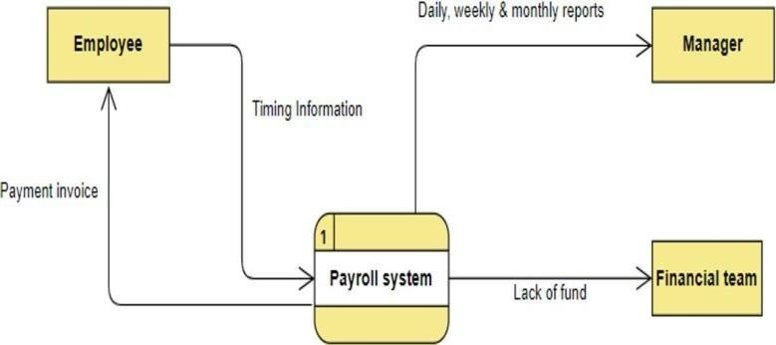

## DFD Level 1:

DFD (data flow diagram) can be drawn to represent the system of different levels of abstraction.

The data flow diagram (DFD) for the payroll system up to level-1 shows the main functions and processes of the system, including data inputs, data processing, and data outputs.

The context 0 process is broken down into:

* Time Tracking process
* Employment Payer Process.

And DFD level 1 diagram, has the following data stores:

* Time Tracking Store: Contains all the tracking data for a user
* Payment Record: Payment record contains all the payments done to the employer

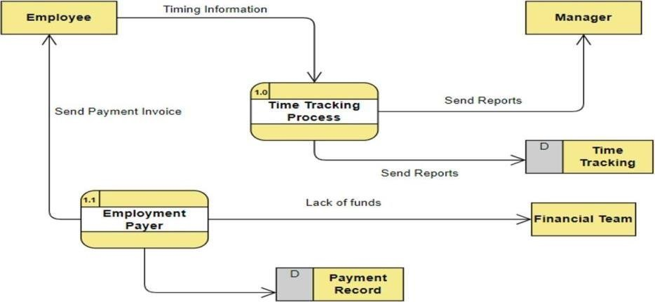

## DFD Level 2:

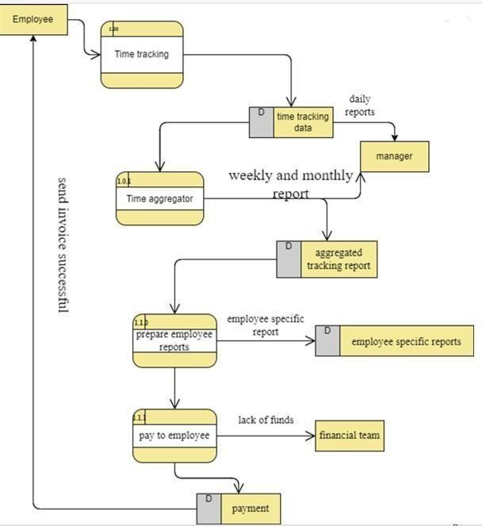

# Use Case Diagram

A UML use case diagram is the primary form of system/software requirements for a new software program underdeveloped. It is a graphical depiction of a user's possible interactions

with a system and shows various use cases and different types of users the system has, represented by either circles or ellipses, with actors often shown as stick figures.

The diagram includes five actors: Manager, Employee, Payment Server, Database Server, and Application Server. The use cases are grouped by the actors they are associated with.

The Manager actor has three use cases:

* 1. Register new manager: This use case allows the Manager actor to register a new manager account in the payroll system.
  2. Register new employee: This use case allows the Manager actor to register a new employee account in the payroll system.
  3. Login: This use case allows the Manager actor to log in to the payroll system and access their account.

The Employee actor has four use cases:

* 1. Track time: This use case allows the Employee actor to track the time they spend working. It is an extended use case that includes two sub-use cases: track start time and time tracking duration.
  2. Time tracking report: This use case allows the Employee actor to generate a report of the time they have tracked.
  3. Payment report: This use case allows the Employee actor to generate a report of the payments they have received.
  4. Login: This use case allows the Employee actor to log in to the payroll system and access their account.

The Financial Team actor has one use case:

* 1. Access financial reports in case of failure: This use case allows the Financial Team actor to access financial reports in case of a failure in the payroll system. It is an included use case that requires the Financial Team actor to log in to the system.

The Payment Server actor has one use case:

* 1. Pays the employee: This use case allows the Payment Server actor to pay the employee. It is an included use case that requires the Payment Server actor to generate a payment invoice.

The Database Server and Application Server actors do not have any associated use cases, as they are infrastructure components that support the functionality of the payroll system.

In summary, the use case diagram outlines the functionality of the payroll system, including the various actors and use cases involved in managing employee accounts, tracking time, generating reports, and processing payments.

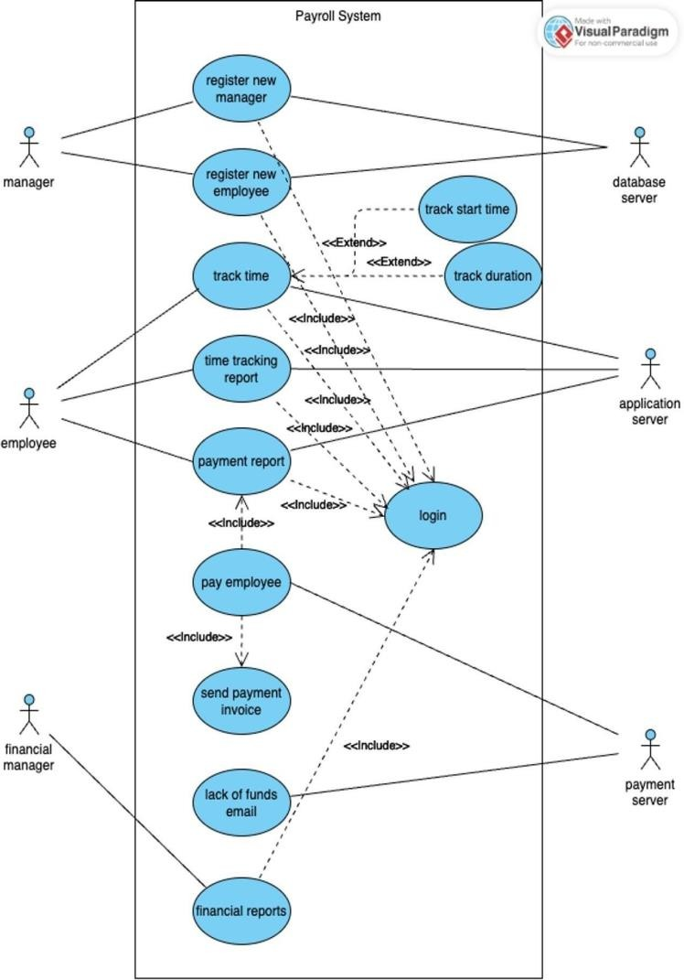

# Class Diagram

The class diagram represents the entities and their relationships in the payroll system. The main class is Person which has attributes such as name, phone, date of birth, email, and password, as well as a method to calculate age. This class is inherited by Manager, Employee, and Financial Officer.

The Manager class has attributes such as manager_id, and methods to create an employee or a manager, get timing and payment reports, and login. The Employee class has attributes such as employee_id, manager_id, and rate, as well as methods to get timing and payment reports, and login. The Financial Officer class has an officer_id attribute and methods to get reports and login.

The Time Tracking class has attributes such as tracking_id, employee_id, start_date, duration, and note, as well as methods to report to the employee and manager. The Payment class has attributes such as payment_id, employee_id, paid_amount, payment_date, and methods to report to finance and send an invoice. The Payment Receipt class has an amount and currency attribute, as well as a method to get employee details.

The relationships between the classes are also shown in the diagram. Payment has a one-to-one relationship with Payment Receipt, meaning each payment has one corresponding receipt.

Manager has a one-to-many relationship with Employee, meaning

each manager can have multiple employees. Employee has a one-to-many relationship with Payment and Time Tracking, meaning each employee can have multiple payments and time tracking entries. Overall, the class diagram provides a clear understanding of the entities, their attributes, methods, and relationships in the payroll system.

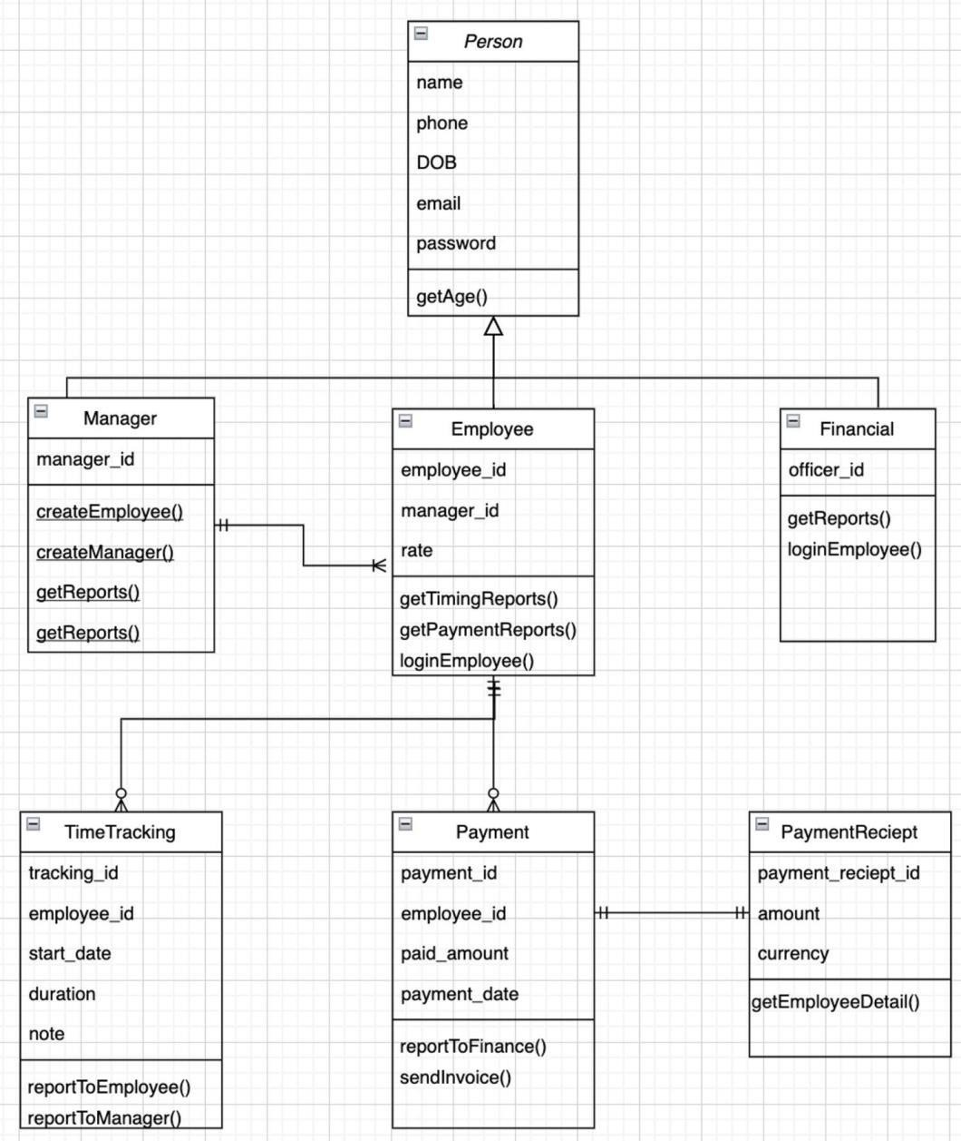

# Sequential Diagram

The diagram depicts the flow of events that occur between the Manager, Employee, Application Server, Database Server, and Payment Server components in the payroll system. First, the Manager logs in to the Application Server by sending their credentials. The Application Server then checks the Database Server for valid credentials and responds to the Manager with a login status.

Next, the Employee initiates a time tracking request by sending a request to the Application Server. The Employee then terminates the time tracking request. The Application Server creates a time tracking entry in the Database Server and the Database Server responds with a successful data insertion status. The Manager is then sent a report for the corresponding timing entry.

At the end of the month, the Database Server sends a monthly report to the Payment Server. The Payment Server then creates a payment using third-party services and a receipt is saved in the Database Server for the particular payment. The receipt is then sent to both the Manager and the Employee.

In summary, the sequential diagram illustrates the steps involved in logging in, tracking time, and generating payment reports in the payroll system, as well as the communication flow between the various components of the system.

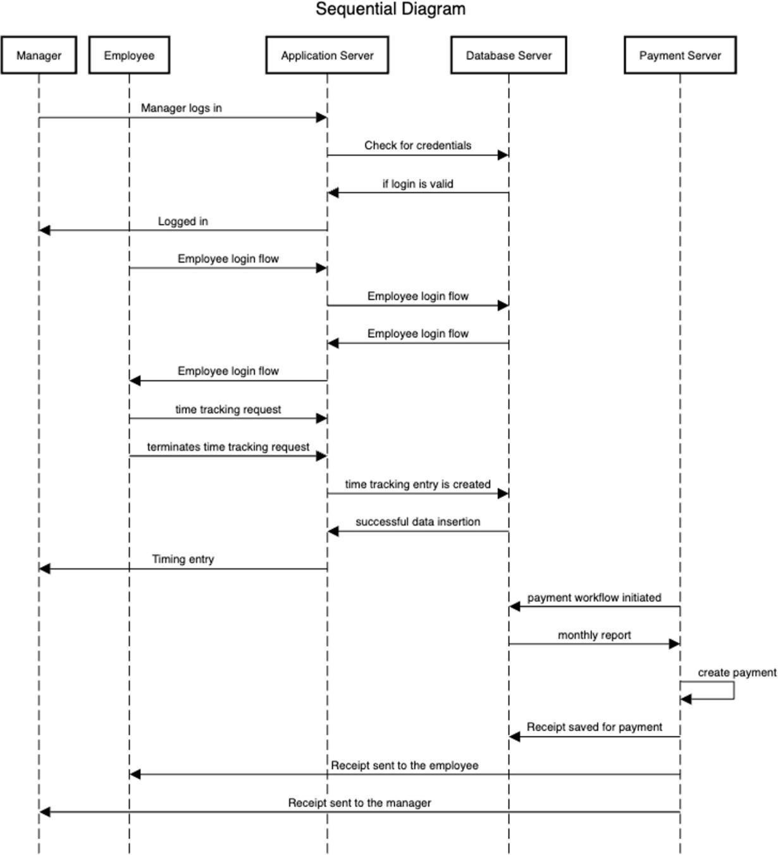

# Activity Diagram

1. The user logs into the system by entering their username and password.
2. If the user is an employee, they have the option to see their payment records and historical time track. They can also end or start tracking their time.
3. If the user is not an employee, they have the option to create a new employee or create a new manager. They can also see timing data.
4. If the user chooses to create a new employee, they will be prompted to enter the employee's details.
5. If the user decides to create a new manager, they will be prompted to enter the manager's details.
6. If the user picks to see timing data, they will be shown the relevant data.

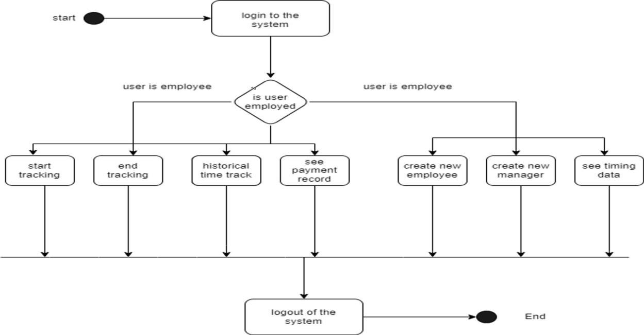

# E-R Diagram

An ER diagram is a visual representation of the data model that shows the relationships between entities in a system. In the context of a payroll management system, key entities typically includes:

* 1. Employee
  2. Attributes
  3. Payroll

Entities are connected by relationships. For example:

An Employee, so there's a relationship between Employee and Salary Information entities.

An Employee receives payroll and may have Tax Information, creating a relationship between Employee and Tax Information entities.

An employee and payroll are managed by the manager creating a relationship between employee and manager and also between manager and payroll.

Each entity has attributes that describe the properties of that entity, and relationships define how different entities are connected. The ER diagram helps in understanding the overall structure of the payroll management system and how different components relate to each other.

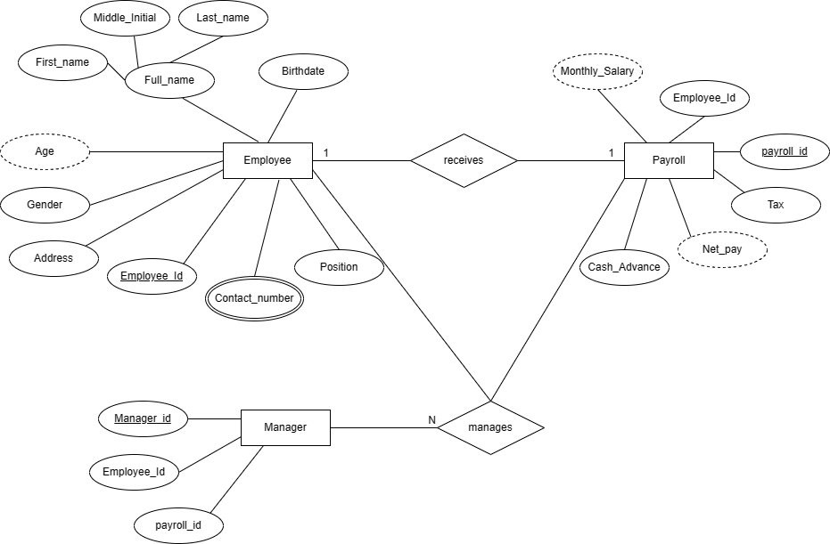

# Decision Table

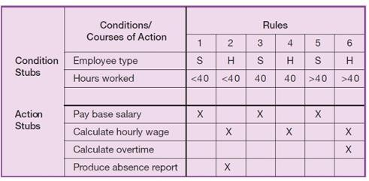

The decision table depicts the flow for payroll management on the basis of the following conditions.

* 1. There are two condition stubs for employee type and hours worked. Employee type has two values: “S,” which stands for salaried, and “H,” which stands for hourly.
  2. Hours worked has three values: less than 40, exactly 40, and more than 40.
  3. The action stubs contain all the possible courses of action
  4. The action stubs contain all the possible courses of action that result from combining values of the condition stubs. There are four possible courses of action in this table: Pay Base Salary, Calculate Hourly Wage, Calculate Overtime, and Produce Absence Report.

We can see that not all actions are triggered by all combinations of conditions. Instead, specific combinations trigger specific actions. The part of the table that links conditions to actions is the section that contains the rules.

To read the rules, start by reading the values of the conditions as specified in the first column: Employee type is “S,” or salaried, and hours worked is less than 40. When both of these conditions occur, the payroll system is to pay the base salary.

In the next column, the values are “H” and “<40”, meaning an hourly worker who worked less than 40 hours. In such a situation, the payroll system calculates the hourly wage and makes an entry in the Absence Report. Rule 3 addresses the situation when a salaried employee works exactly 40 hours

# Decision Tree

Decision tree is a graphical representation of a decision situation in which decision situation points (nodes) are connected together by arcs (one for each alternative on a decision) and terminate in ovals (the action that is the result of all of the decisions made on the path leading to that oval). before.

The figure below shows the decision tree for the payroll system discussed:

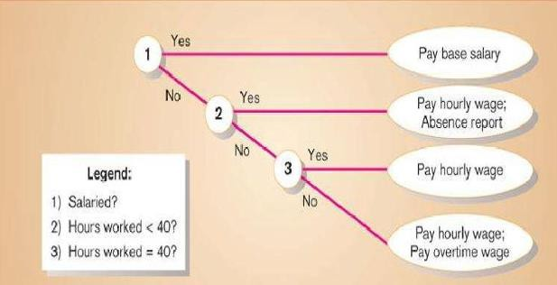

# Limitations and Future Work

Currently, the Payroll Management System is designed with efficient payroll processing in mind, and is intended for deployment in technically sophisticated organizations. It might not be as applicable to a larger audience, though. Simplifying the system's user interaction is necessary to improve user experience because it will be easier to use and more relevant for the intended users. The present design of the system places a strong emphasis on technological features, possibly ignoring user group considerations and management protocols, which could negatively affect the project's outcome. The current report should be thoroughly updated and modified in the future, with any missing information that is essential to the system's overall performance and effectiveness in various organizational contexts being addressed.

# Conclusion

The current approach to payroll management system deals with various aspects of employee compensation, ensuring accuracy and efficiency. This insight guides the design of a relevant and streamlined payroll management system that can be effectively managed through an automated computer system. Users can easily inquire about payroll details, submit requests, and interact with the management seamlessly using the computer system. This automation results in faster and more efficient processing of payroll tasks, contributing to an overall improvement in the payroll management process.

# References

**Modern System Analysis and Design,** Joffrey A. Hoffer, Joey F. George, Joseph S. Valacich, Pearson Publication 6th Edition